**The Ising Model**

Mark Murray

14320269

**Abstract:** The aim of this assignment was to further our understanding of and investigate the Ising model. A collinear matrix was created and then a sweeping function was made to sweep through numerous times changing the spin of an element if required.

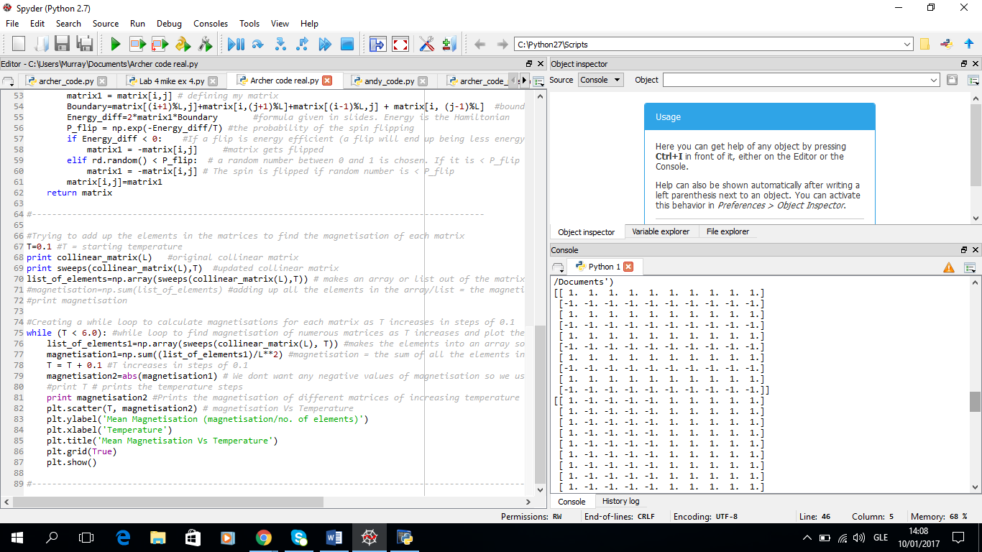 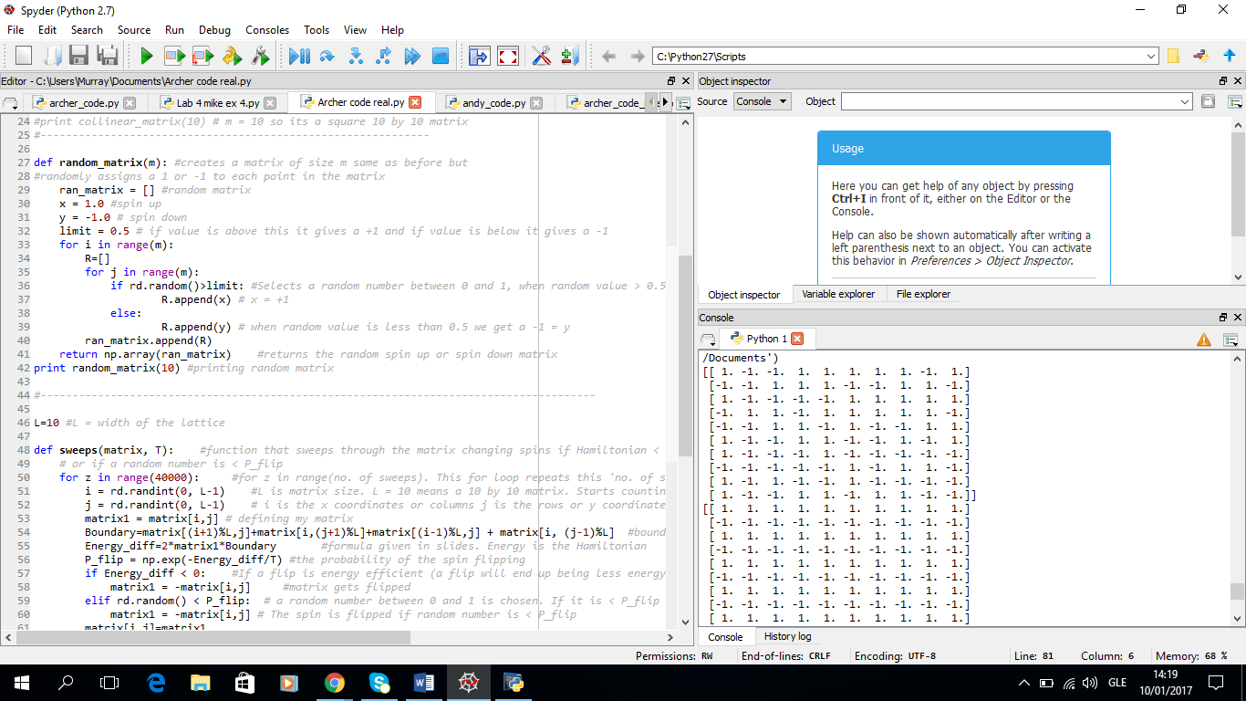

Fig. 1 Fig. 2

Figure 1 shows a 10 by 10 collinear matrix

Figure 2 shows a 10 by 10 random matrix

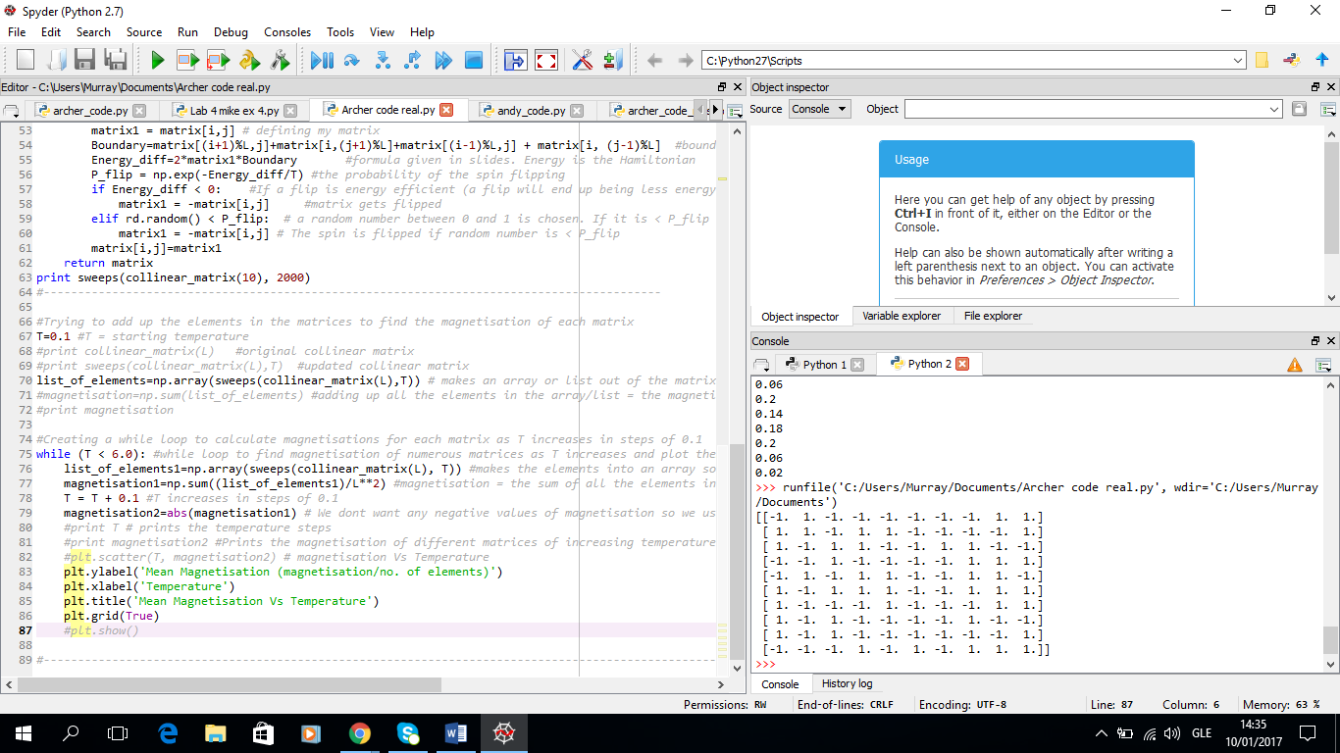

Fig. 3

Figure 3 shows a collinear matrix that is swept 50,000 times with a temperature of 2000. The system has reached equilibrium and no pattern is present.

|  |  |
| --- | --- |
| **Temperature** | **Mean Magnetisation** |
| 0.1 | 1 |
| 0.5 | 1 |
| 1.0 | 1 |
| 1.5 | 1 |
| 2.0 | 0.98 |
| 2.5 | 0.62 |
| 3.0 | 0.18 |
| 3.5 | 0.2 |
| 4.0 | 0.26 |
| 4.5 | 0.12 |
| 5.0 | 0.02 |
| 5.5 | 0.18 |
| 6.0 | 0.02 |

Table 1.

Table 1 shows the calculated magnetisation values for different temperatures through 50,000 sweeps. 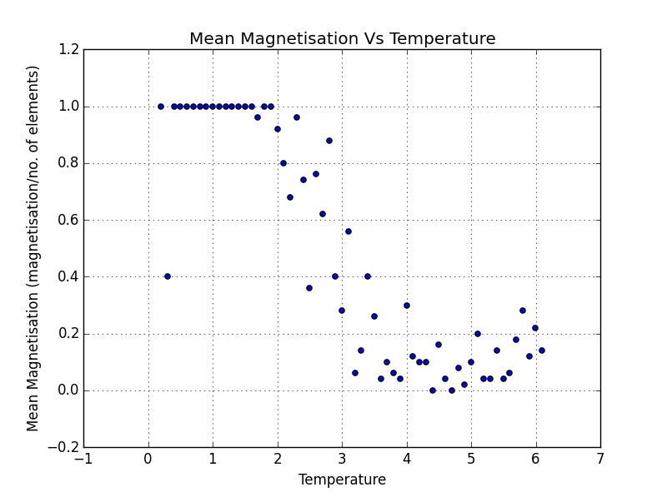

Fig. 4

Figure 4 shows the graph of Mean Magnetisation Vs Temperature.

The graph is for 50,000 sweeps and a 10 by 10 matrix. The general trend is as expected.

**Introduction:** In this problem we focused on the 2 dimensional Ising model. In this the Ising model consists of a 2 dimensional square lattice where each element of the lattice can be in one of two states; +1 (spin up) or -1 (spin down). Each element can interact with its neighbouring elements and there is a probability of a spin up flipping to a spin down or vice versa, depending on its neighbour’s values. The probability of a spin flipping is given by:

$${P_{flip}=e}^{\frac{ΔE}{k_{B}T}}$$

Where $ΔE$ = $E_{2}-E_{1}$

Here $E_{2}$ is the energy if the element’s spin was flipped and

$E_{1}$ is the energy of the element in the matrix before it is flipped.

If $ΔE$ < 0 then the element is flipped because the system wants to reach as low an energy state as possible. The system actually saves energy by flipping the element’s spin.

However if $ΔE$ > 0 then the element can flip with a probability of $P_{flip}.$

The energies are found by summing an element’s four nearest neighbours and multiplying by the spin in question and by minus the exchange energy (J).

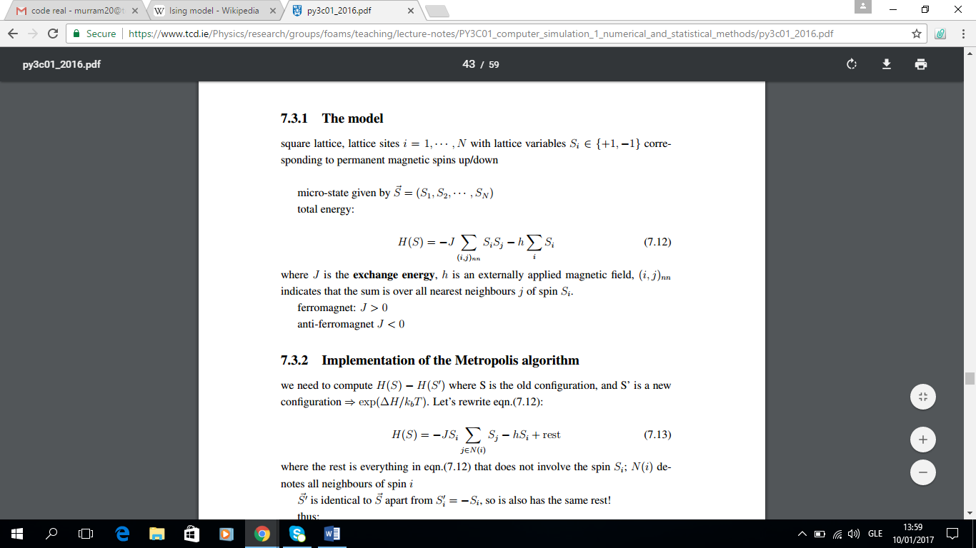

Where h is an external magnetic field which is zero for now.

Magnetisation: The magnetisation can be calculated by adding up all the elements in a matrix. The total sum of all elements is the magnetisation of the system.

**Methods:**

Metropolis Algorithm Method

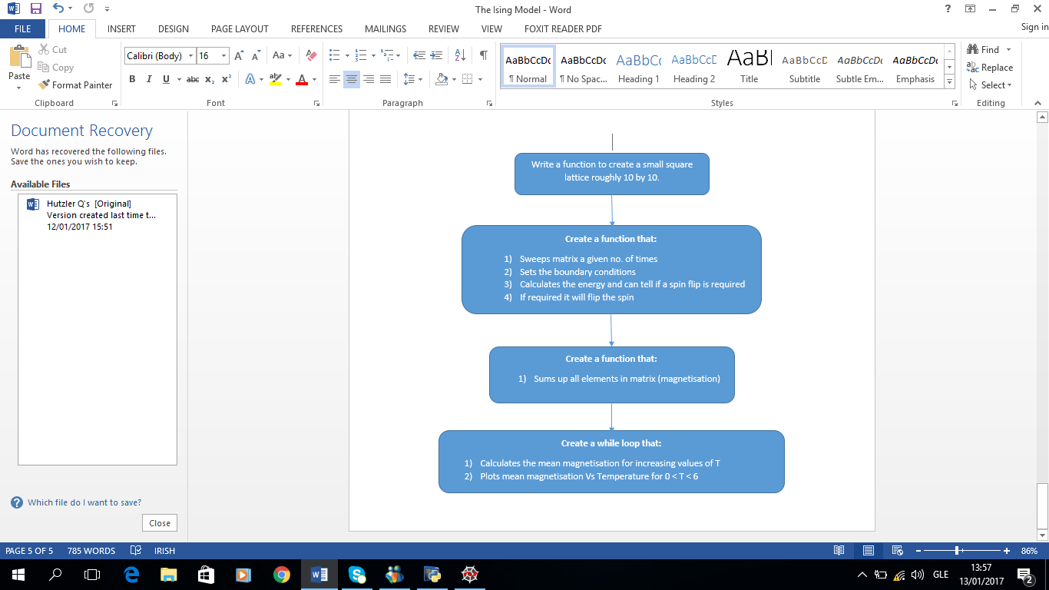

This algorithm just requires knowing the probability of a spin flip.

$${P_{flip}=e}^{\frac{ΔE}{k_{B}T}}$$

So all we need is to calculate the $ΔE$ value and set a value for T.

$k_{B} is a constant so can be left out to simplify things$.

The starting configuration for the lattice can be either the collinear matrix or the random matrix we created. After the algorithm has run many times eg: > 50,000 sweeps for a 10 by 10 lattice, the elements should no longer have a pattern (ferromagnetic) to them and should be random (antiferromagnetic). Now the mean magnetisation of the lattices can be calculated for different values of T.

Table 1.

|  |  |
| --- | --- |
| **Temperature** | **Mean Magnetisation** |
| 0.1 | 1 |
| 0.5 | 1 |
| 1.0 | 1 |
| 1.5 | 1 |
| 2.0 | 0.98 |
| 2.5 | 0.62 |
| 3.0 | 0.18 |
| 3.5 | 0.2 |
| 4.0 | 0.26 |
| 4.5 | 0.12 |
| 5.0 | 0.02 |
| 5.5 | 0.18 |
| 6.0 | 0.02 |

Table 1 shows the calculated magnetisation values for different temperatures through 50,000 sweeps. Note that temperature increased by 0.1 not 0.5 but this is just to show the general trend. The mean magnetisation is the calculated magnetisation divided by the number of elements in the matrix ${(L}^{2})$.



Fig. 4

Figure 4 shows the graph of Mean Magnetisation Vs Temperature. The graph is for 50,000 sweeps and a 10 by 10 matrix. The general trend is as expected.

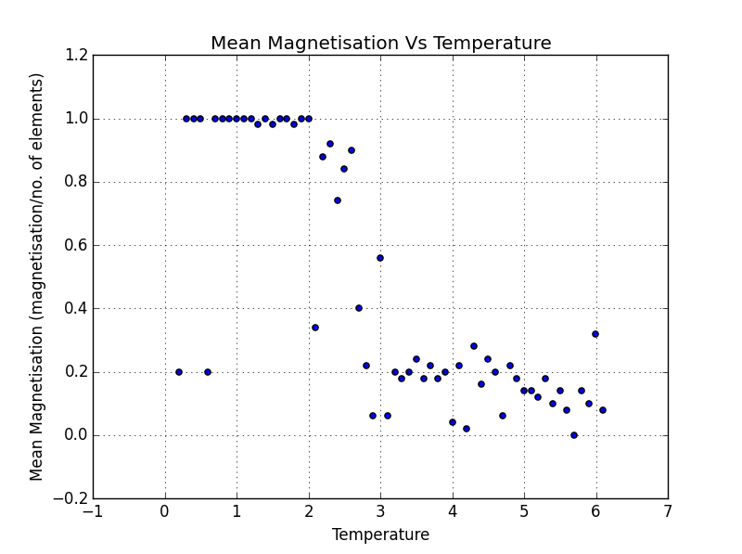

Fig. 5

Figure 5 shows the same 10 by 10 matrix but for 200,000 sweeps.

Notice how the drop from 1 to 0 is slightly steeper for the 200,000 sweeps. The point at which the slope of these two graphs differs and one becomes steeper than the other is known as the critical temperature or Curie Temperature (Tc). Once the temperature exceeds this Tc value there is a phase transition. Above this temperature the materials spins are random and the material is no longer ferromagnetic.

No matter the lattice size, every graph will go through this Tc point. However a larger lattice will have a steeper slope, similar to a smaller lattice with more sweeps. This is exactly what we expect, that as the no. of sweeps approaches infinite this drop off line just after the Tc value approaches minus infinite slope. Real life problems would have a much larger lattice size than a simple 10 by 10 matrix and therefore the slope would be almost vertical. This shows that the Metropolis algorithm is just a way of estimating real world systems and is not 100% accurate.

**Conclusions:** The two variables here are lattice size and number of sweeps. Both of these have an effect on the trend between mean magnetisation and temperature. However neither of these variables have an effect on the critical temperature. This is a property of the material due to it’s bonds and how it’s atoms interact. The critical temperature for a material is 2.269J/ $k_{B}$. Larger lattices, L > 20, require far more sweeps for the magnetisation values to be as accurate. Even 400,000 sweeps is not enough for a 32 by 32 lattice to find the correct relationship between temperature and mean magnetisation. More than 400,000 sweeps takes a very long time to load so it is not very practical. Similarly if the lattice is very small say 2 by 2 the data set is too small to get accurate results. The Metropolis algorithm is only used to see trends in fairly small data sets not real life systems. A real life system may have as many elements as ${10}^{7}x{10}^{7}x{10}^{7}$. This would also be 3 dimensional. This number is too large to use in an algorithm like this so statistics and smaller data sets are used to find trends. By simplifying the problem into 2 or even 1 dimension trends can be found in the data, which is what we did for this assignment.